**Reg. No. 21BCE1297 Name: Vidhi Shah Date of Practical: 16/03/22**

**Experiment 4**

**Aim:**

Study of input and output characteristics of CE BJT (Common Emitter Bipolar Junction Transistor) amplifier using LTSpice.

**Tools and Apparatus:**

­LTSpice, Transistor, Resistors, Voltage Source

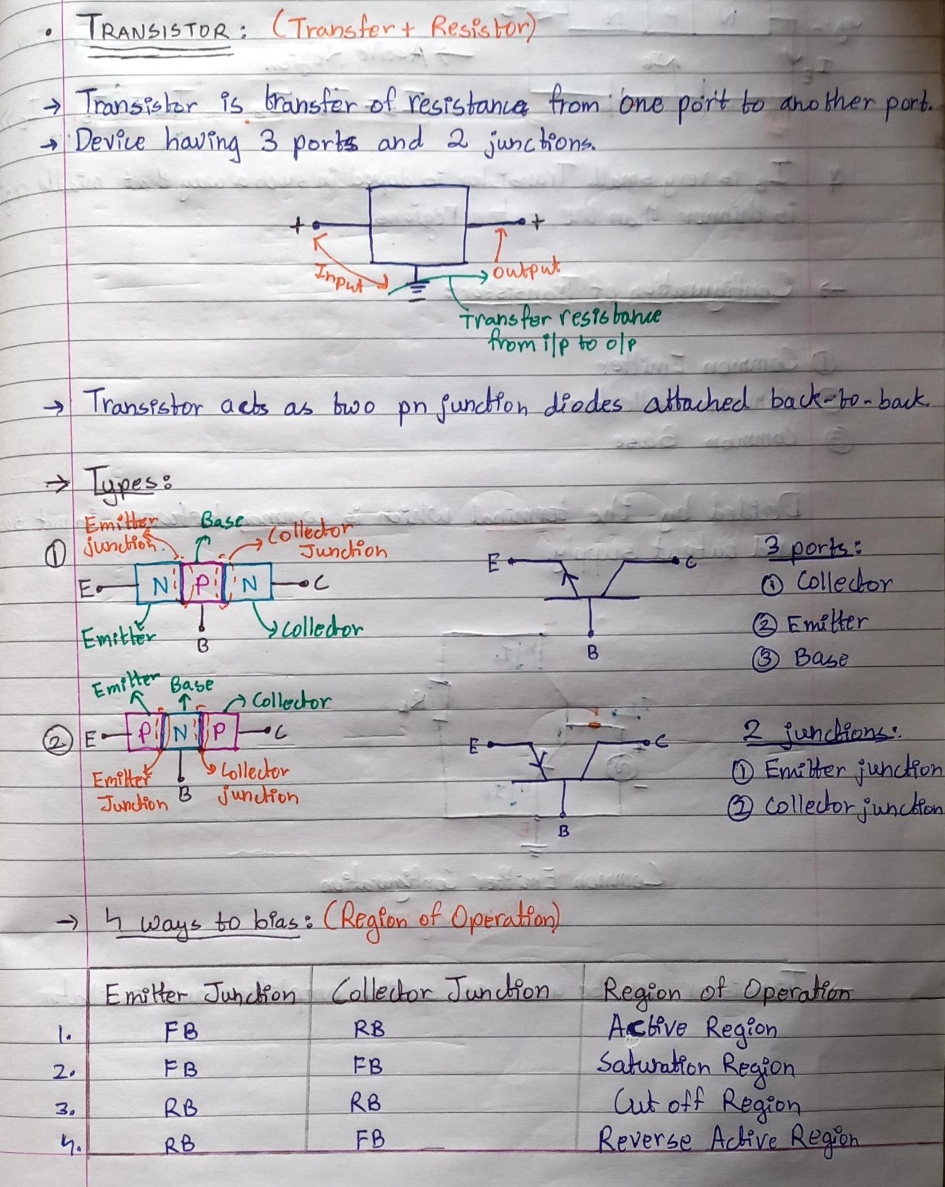**Theory and Design:**

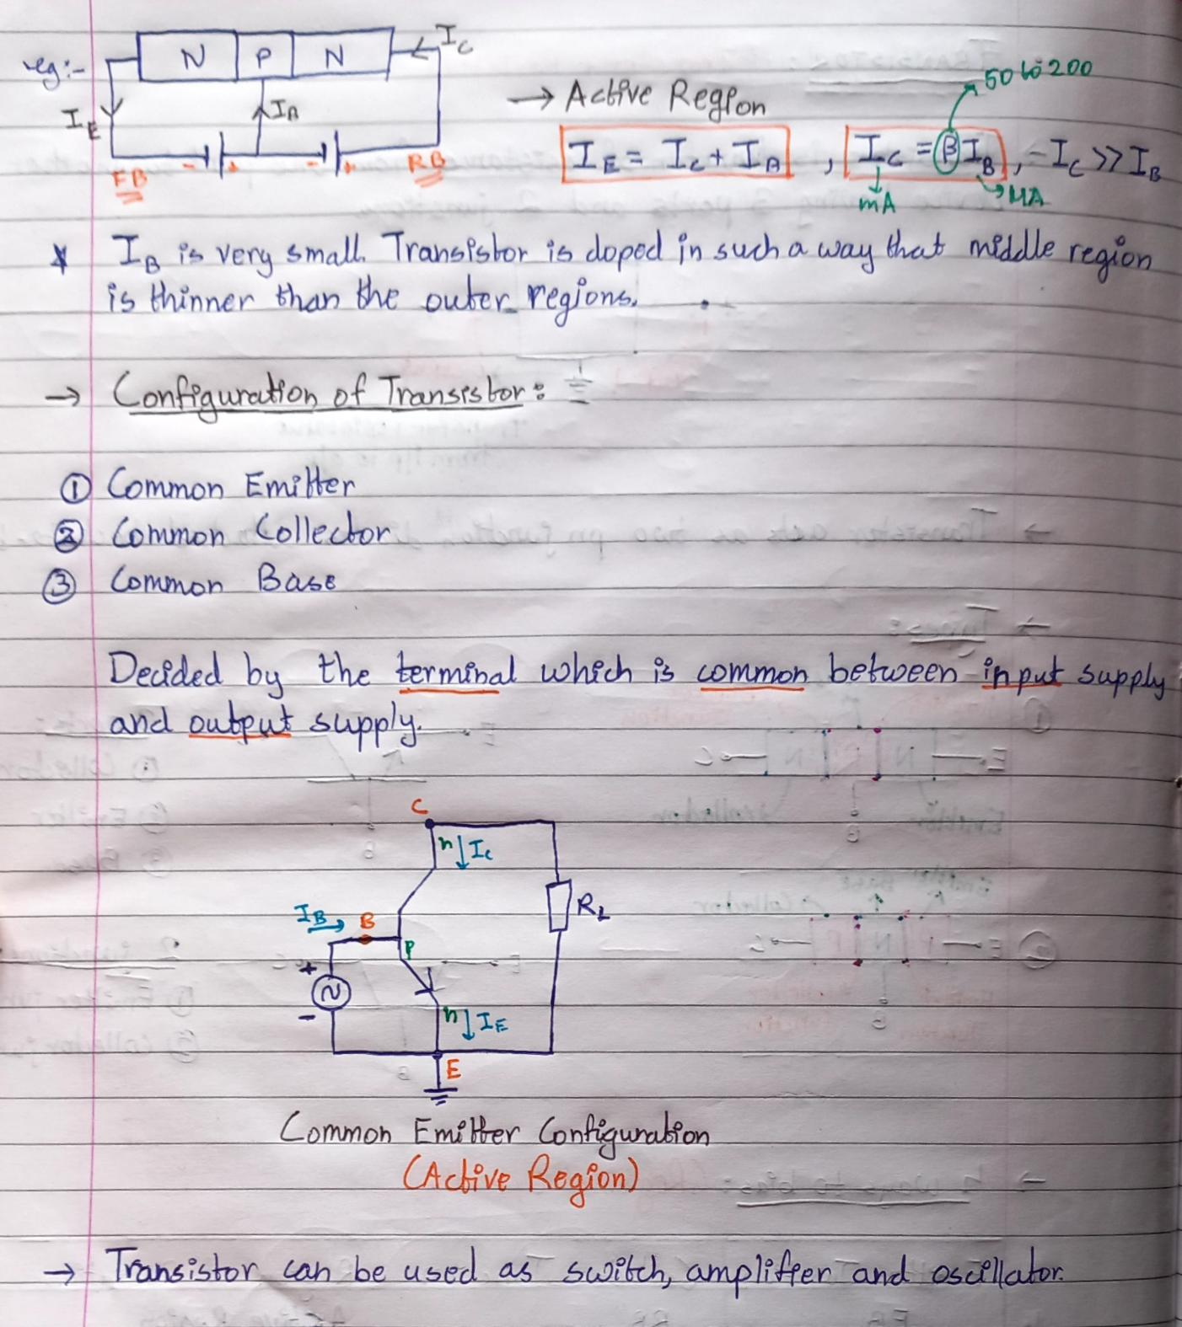

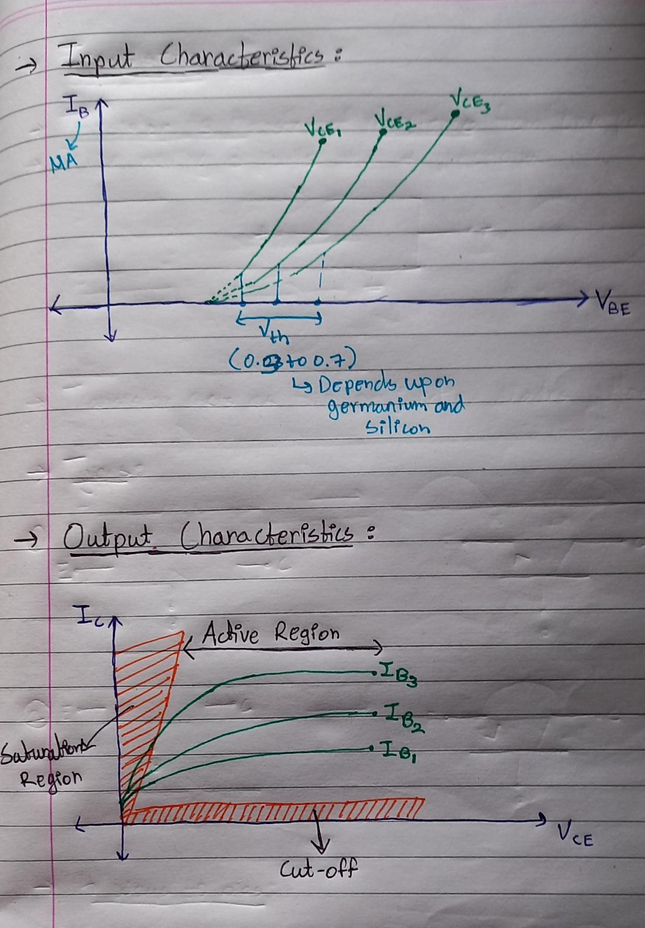

**Simulation Results:**

1. **Input Characteristics**

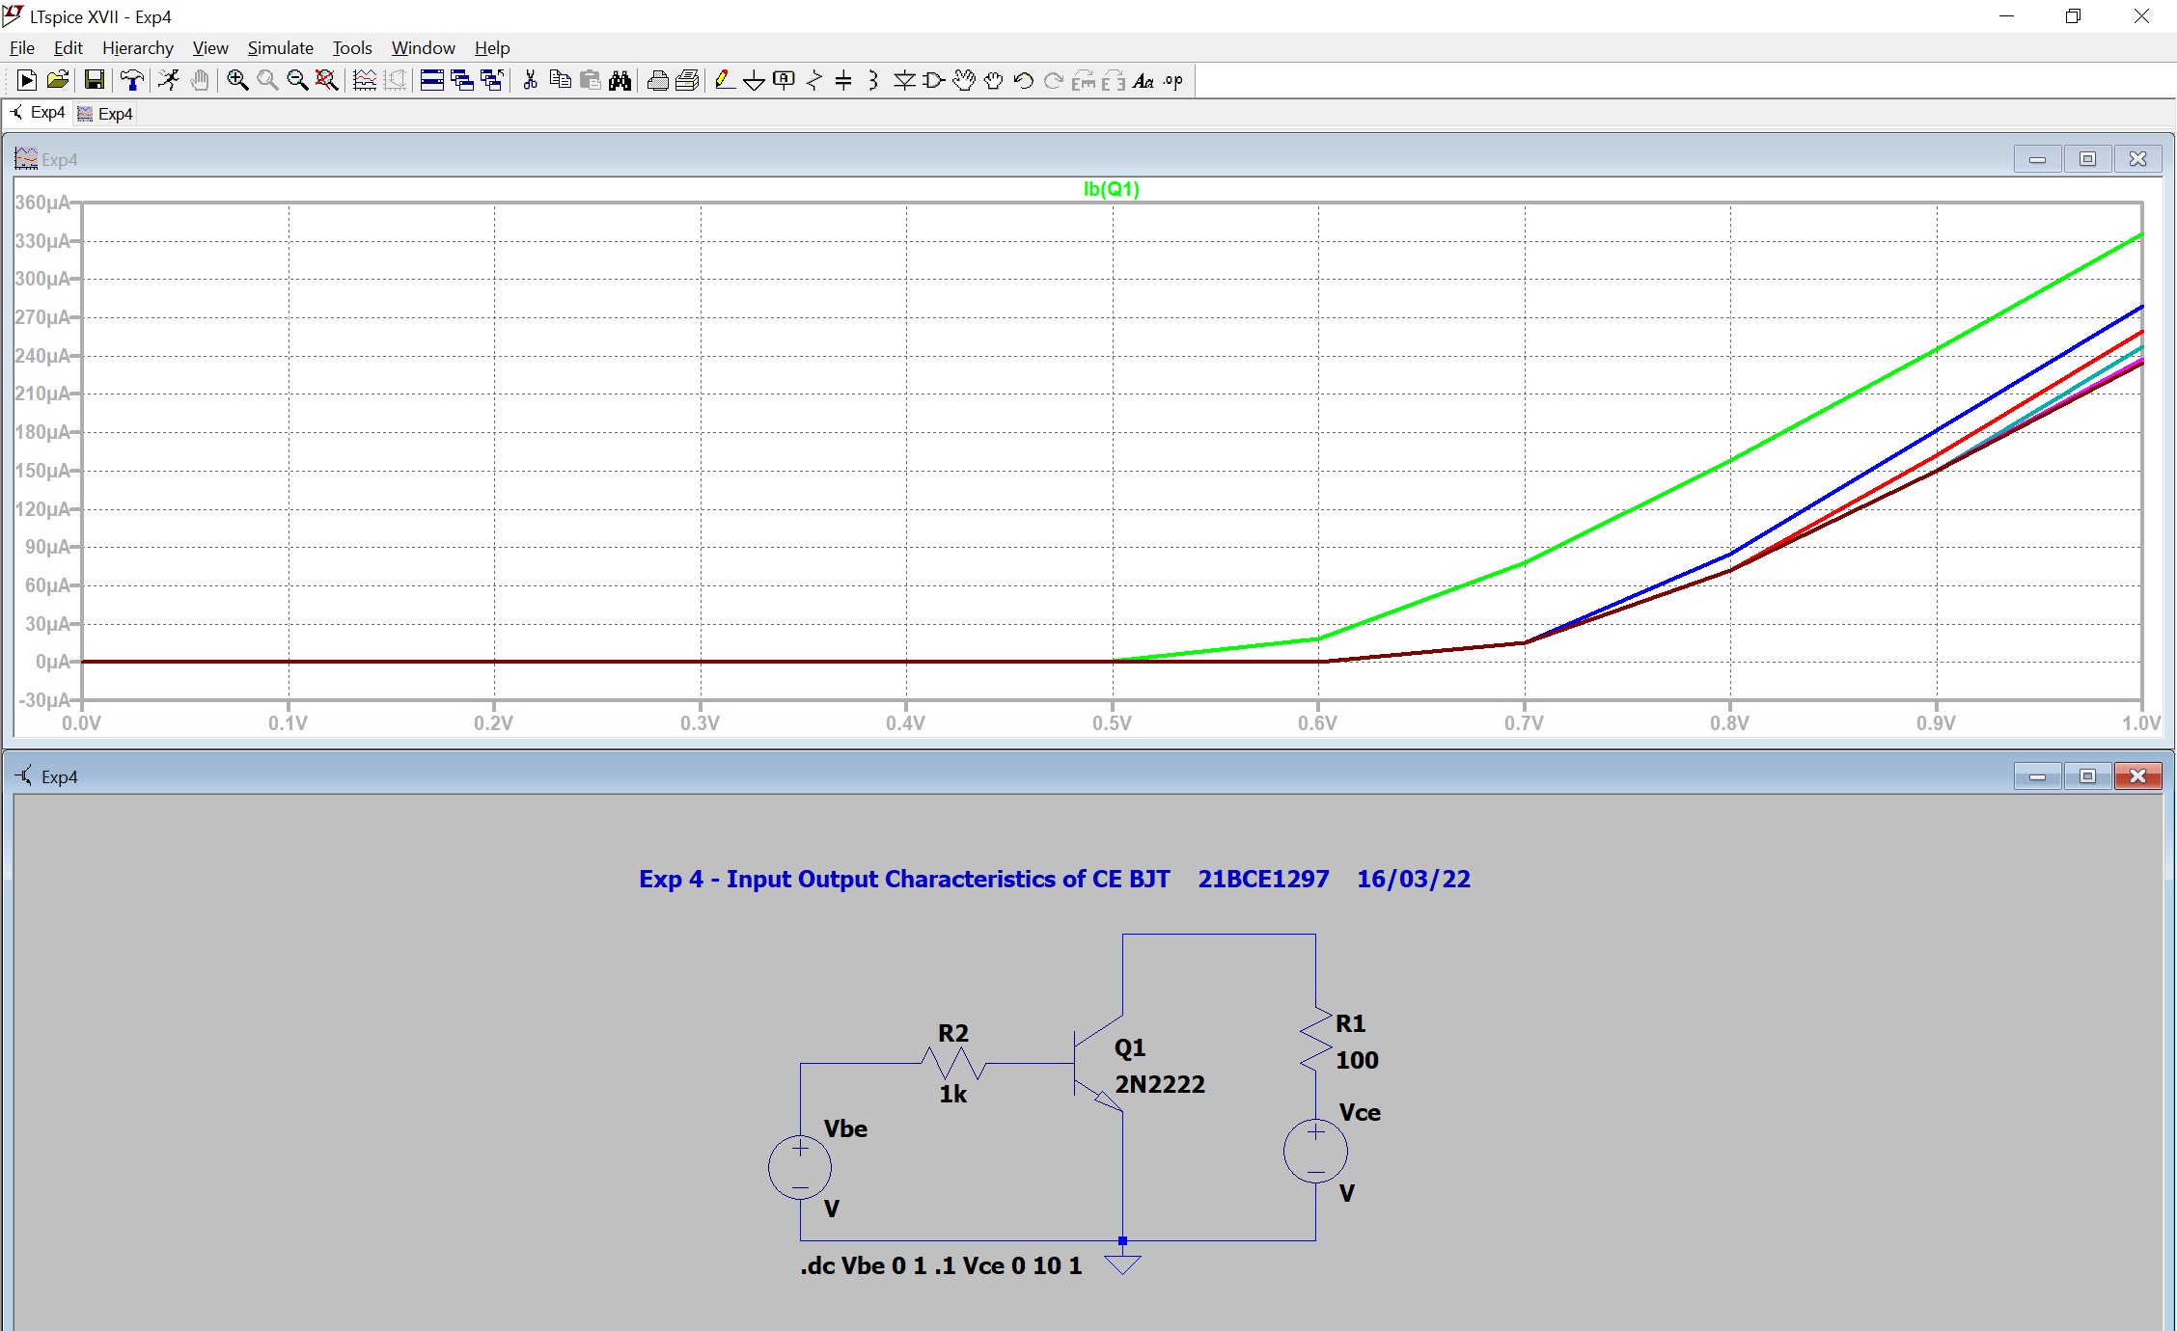

1. **Output Characteristics**

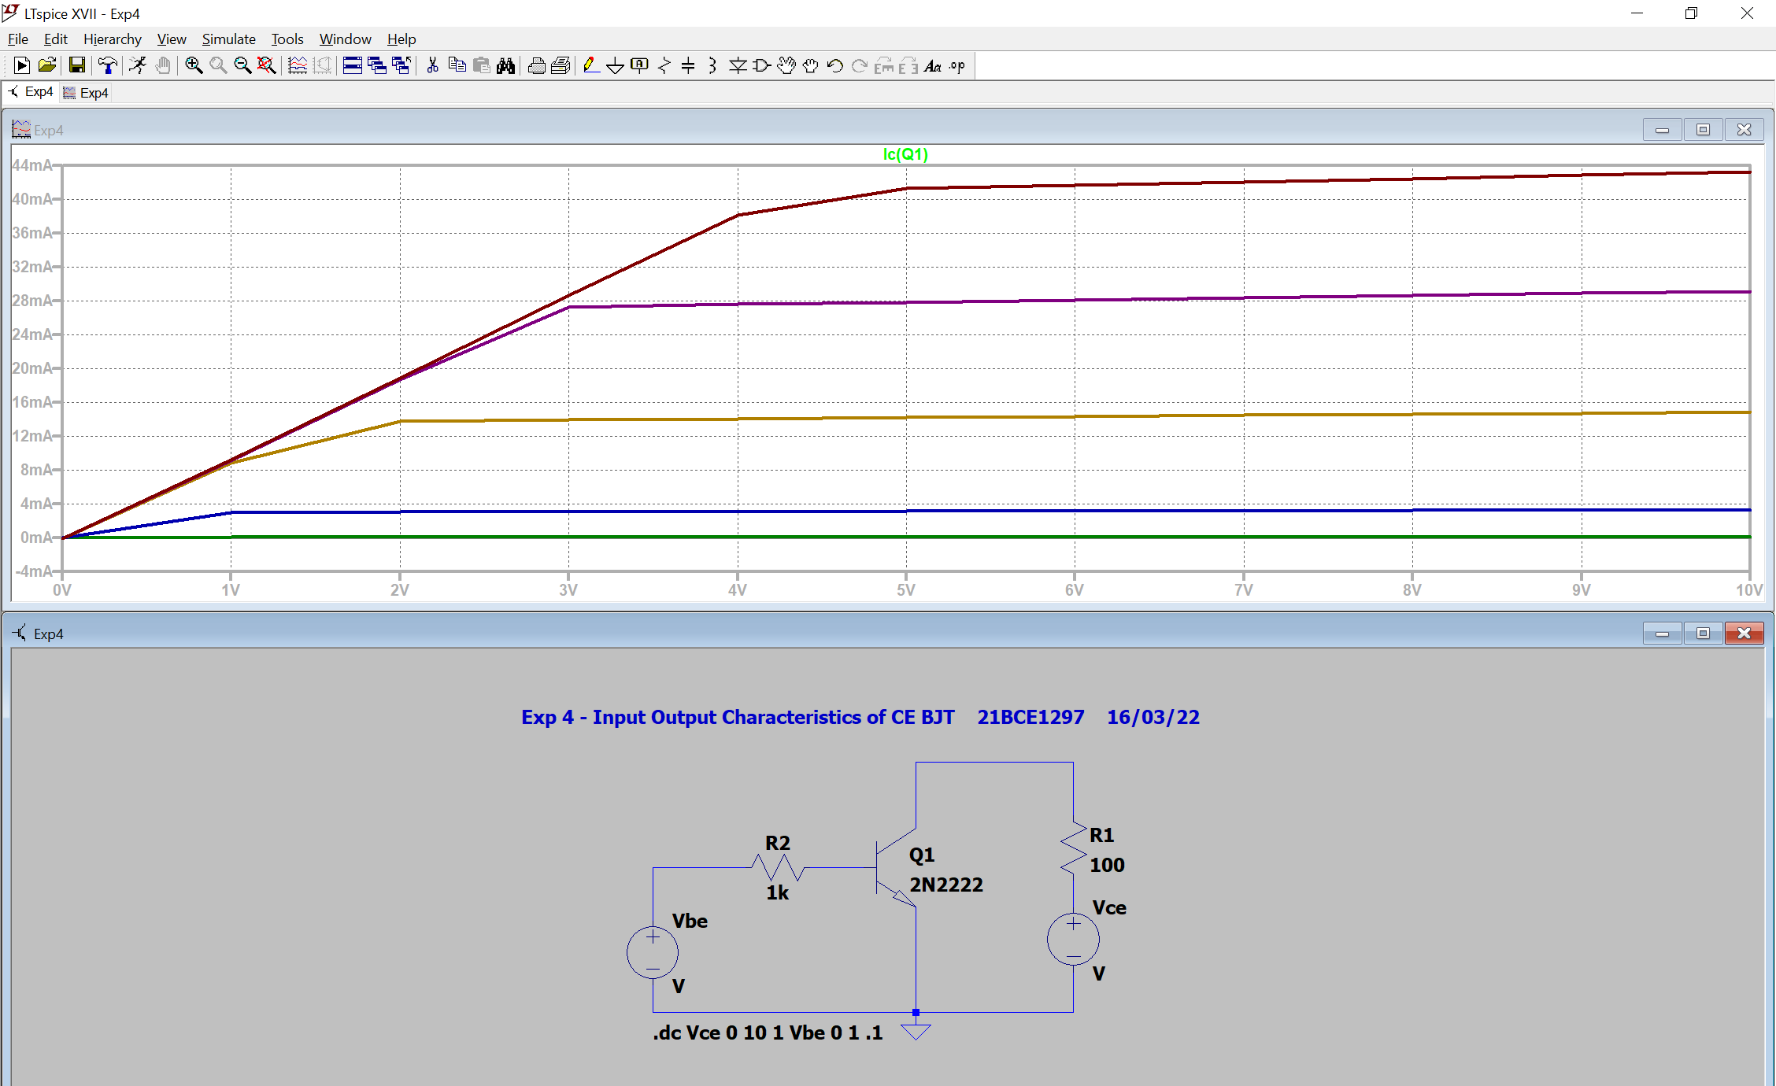

**Conclusion:**

1. **Input Characteristics:**
   1. **For VCE1 (Green)**
      1. VBE1 = 800 mV -> IB1 = 157.87 µA
      2. VBE2 = 900 mV -> IB2 = 244.98 µA
      3. Change in VBE = 100 mV, Change in IB = 87.11 µA
      4. $\frac{ΔI_{B}}{ΔV_{BE}}$ = 0.87
   2. **For IB = 210 µA**
      1. VCE1 -> VBE1 = 859.84 mV (Green)
      2. VCE2 -> VBE2 = 929.04 mV (Blue)
      3. VCE3 -> VBE3 = 949.23 mV (Red)
2. **Output Characteristics:**
   1. **For VCE = 7V**
      1. IB5 -> IC =42.07 mA (Brown)
      2. IB4 -> IC =28.37 mA (Purple)
      3. IB3 -> IC =14.47 mA (Yellow)

**Inferences:**

1. Transistors transfer resistance.
2. Transistors can be used as amplifiers (IC >> IB).
3. Select npn transistor
4. Keep first source in DC Sweep as VBE for input characteristics and as VCE for output characteristics.
5. While plotting graph, click on the respective transistor terminal and not the wire.
6. Connect all wires properly.